Business Requirement Document for QSR

# 1. About Company

QSR is one of India largest Fast Foods restaurant chain and serving millions of customer daily across various cities in India with more than 1000 restaurant and have largest SKU in the industry

# 2. Objective

The goal is to create Dashboard where we can check our Financial Performance, How we can Optimize our Businessand Budgeting

# 3. Key Focus Areas:

1. **Financial Performance Analysis**:

* Metrics like overall sales, gross profit, EBIT, SKU analysis.
* Year-on-year (YoY) changes and trends.
* Breakdown of sales by category, location, and sales channel.

2. **Business Optimization**:

* Identifying top categories based on gross profit and net revenue.
* Pareto analysis (80-20 rule for SKU contribution).
* Gross profit and volume comparison, quadrant analysis of categories and locations.

3. **Budgeting & Financial Planning**:

* Actual vs. budget financial analysis.
* PVM (Price-Volume-Mix) analysis for drivers like sales and EBIT.
* Cost analysis (COGS, marketing, etc.).

# 1. Financial Performance Analysis

* 1. Overall Sales, Gross Profit, EBITDA, PAT ,SKU
  2. **Show YoY Change for Following (Sales, Gross Profit, EBITDA, PAT)**
  3. **Trend of Sales with PAT with PAT%**
  4. **Show 100% stake Column Chart showing (Sales, Gross Profit, EBITDA, PAT)**
  5. **Show Sales by Category & Location**
  6. **Sales Bifurcation by Channel   
     Volume & Trend by Category**

# 2. Business Optimization:

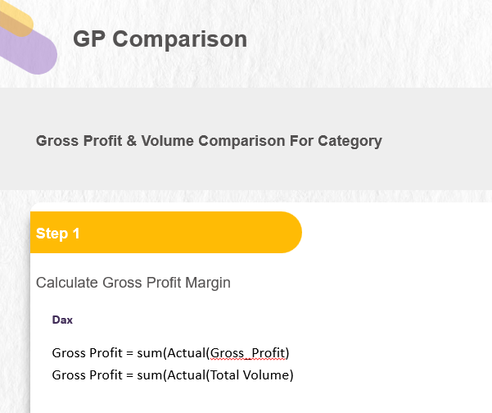 1. **Top Category by Gross Profit & Net Revenue (Scatter Plot)  
 2. Gross Profit & Volume Comparison with Average (Dynamic)  
 3. Pareto Analysis (Level 1,2,3)  
 4. Show highest sales by category and % of SKU Contribution (Mekko Chart)**

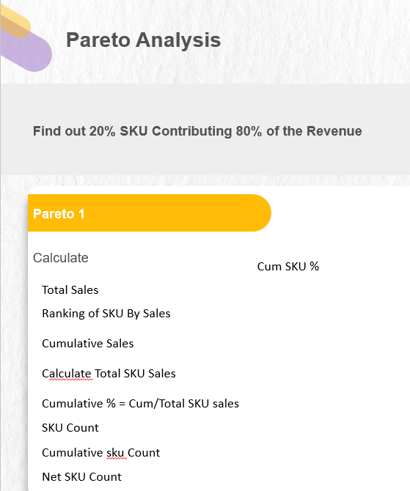**\**

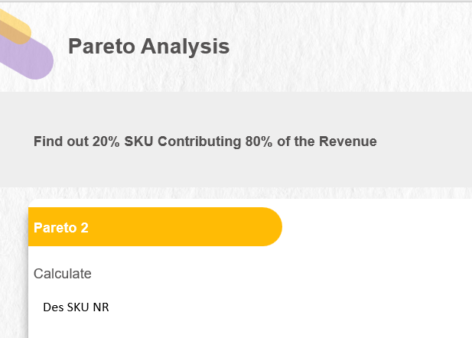

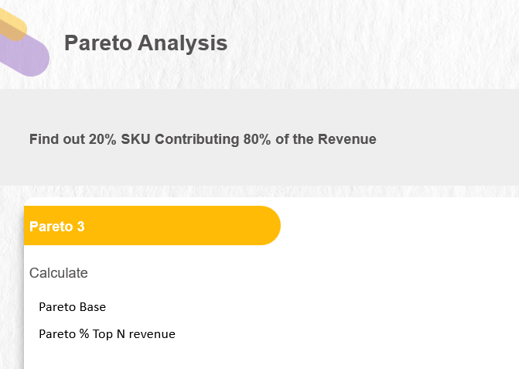

# 3. Budgeting Analysis

* 1. **PVM Analysis**
  2. **Variance Analysis**
  3. **Actual Vs Budget Financial Analysis for Business Drivers ( Sales, EBITDA, PAT, Volume) with Trend YoY**
  4. **Actual Vs Budget Financial Analysis for Cost Drivers ( COGS, Packaging, Marketing) with Trend YoY**

# 9. Conclusion

This report should provide key insights into QSR financial health and business optimization. By leveraging data-driven analytics, the company should able to enhance profitability, streamline operations, and make more informed decisions.